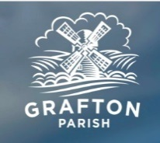

**Agenda for Grafton Parish Council at the Coronation Hall, East Grafton**

**on Monday 07 July 2025 at 19:30**

1. **Apologies**
2. **Matter Arising from previous meeting of the Parish Council held on 12 May 2025**
3. **Public Forum under adjournment**
4. **Planning applications**

* **Application number: PL/2025/05093 Deadline: 11/07/2025**

**Application type: Householder planning permission.**

**Proposal: On the southeast elevation of the thatched barn it is proposed to remove the existing corrugated metal sheet doors and insert new outer timber double door and double-glazed timber framed inner glass screen with double door in its center. The opening will be slightly widened, with the removal of one existing timber stud and adjacent weatherboards.**

**Address: The Croft, Wilton, Marlborough, SN8 3SS**

**Link to the application:**

**https://development.wiltshire.gov.uk/pr/s/planning-application/a0iQ300000EkyUA**

1. **Financial Review**
2. **Parish Updates:**

* Coronation Hall
* Solar panels
* Playing Field Maintenance
* Speed Watch/SID progress
* PCAP
* Defibrillators
* Nominate one supplier and synchronize access codes for all defibrillators
* Community Calendar
* Outcome for Rounders
* Grafton Neighborhood Plan progress
* Parish Steward